SCALEMASTER: MULTI-SCALE MAPMAKING FROM MULTIPLE DATABASE RESOLUTIONS AND FOR MULTIPLE MAP PURPOSES
Cynthia A. Brewer¹, Barbara P. Buttenfield², Charlie Frye³, and Jessica Acosta¹
1 - Pennsylvania State University, Dept. of Geography, University Park, PA, USA
2 - University of Colorado, Dept. of Geography, Boulder, CO, USA
3 - ESRI Inc., Redlands, CA, USA
cbrewer@psu.edu
We present continued work on ScaleMaster, a tool that guides and describes multi-scale map design and combinations of databases at widely ranging resolutions. This work complements multi-representation database (MRDB) research ongoing in Europe which is described in our recent paper on this topic (Brewer and Buttenfield 2007). We used U.S. databases, with the most detailed databases compiled by local governments at an anchor scale of 1:5,000. We also tested draft preprocessed Level of Detail (LoD) hydrography databases at resolutions suited to approximately 1:30,000 and 1:80,000 mapping. These data were used to produce maps at all scales ranging from 1:5,000 to 1:1,000,000 (1:5K to 1:1M). The series of draft maps we discuss were designed for reading at the coarse-resolutions of computer screens using ArcGIS 9.2.
Our demonstration maps were produced primarily using selection, elimination, and symbol design changes. Relying on these changes to the display for mapmaking through scale is in contrast to use of geometry changes produced by generalization operations such as simplification and displacement. We have constructed approximately 30 maps for each of four map types: topographic, zoning, soils, and population density. These topics span the range from reference to thematic mapping and include both human and physical themes. All of the maps are of Ada County, Idaho, with detail for Boise and Meridian cities. Jessica Acosta is the primary designer for the map series with feedback from research team members Cindy Brewer, Charlie Frye, Barbara Buttenfield, and Aileen Buckley. Jessica produced maps at scales throughout the 1:5K to 1:1M range for each topic and also documented her work in ScaleMaster diagrams.
Figure 1 shows a small map section at six scales for our topographic reference mapping. Lines are progressively thinned and eliminated and corresponding labels are likewise eliminated. Small features collapse from areas to points and are eliminated. Detail in the contour lines is not yet well controlled (we eliminated lines rather than the necessary regeneration for these drafts) but the change to hillshading rather than contours is a suitable option at smaller scales. All changes in the map displays that produce these designs are documented in the ScaleMaster diagrams (Figure 2 to 5). The fourteen basic types of design decisions we made for multi-scale mapping are listed in Table 1.
_________________
Table 1. Types of map design decisions for scale change
The letters listed below code each decision in the ScaleMaster diagrams (Figures 2 to 5).

code description
s – size change
c – color change
p – pattern change (e.g., dash, crosshatch)
t – transparency change
l – modify label appearance (e.g., bold, italic, character spacing, leading)
i – improve label positions in relation to nearby features or labels (e.g., overrun, remove duplicates, feature weighting)
o – on/off for aspect of symbol or label (e.g. remove outlines for areas with feature
type still present)
r – reclassify features by attribute (e.g. fewer categories)
f – filter by threshold on feature attribute (e.g., filter on size to remove small parks)
e – eliminate layer or eliminate by feature type (e.g., eliminate intermittent streams)
a – add layer or add by feature type (e.g., add labels for physiographic features classed as large; this is not a geometry change because level of generalization remains similar)
x – change layer order (e.g., roads moved from beneath transparent area to above)
R – use ArcGIS Representation tools (e.g., set endings of dashes with full pattern)
G – geometry change (e.g., new data set or new layer with generalized features)
_________________
The ScaleMaster diagrams (Figures 2 to 5) share the same structure. Scales from 1:5K to 1:1M form a horizontal logarithmic axis; example scales are listed across the top of the diagrams. Map feature types are grouped and listed vertically. For example, the first group of blue bars represent mapping decisions for hydrographic area, line, and point features. Narrower bars at the bottom of each group list decisions for map labels.
To understand coding across the ScaleMaster diagrams, examine the topographic map ScaleMaster (Figure 2) and note the eight vertical breaks along the first red bar for roads in the Transportation group. Each break (listed in Table 2) is first annotated with a number (its sequence along the bar) and then one or more letter codes (listed in Table 1) that refer to the types of design decisions made at that scale. Changes in geometry (G) that bring a new database to the design are also marked by use of a lighter color in the bar. Designs at smaller scales combine data from a variety of anchor and LoD database resolutions.
_________________
Table 2. Changes made to roads listed on the ScaleMaster for topographic mapping (codes at each break along first red bar in Figure 2).

scale code description
20K: 1Go - change geometry (from polygons to lines); remove casing for small roads
25K: 2s - reduce symbol size for small (white) roads (from 2 pt to 1.5 pt)
50K: 3erc - reduce number of white roads and reclassify into 4 categories; lighter casing for Principal Arterial roads (from 50% to 30% grays)
70K: 4e - remove Major Collectors and Park roads (reduce road categories to 3)
120K: 5e - fewer features on Principal Arterial roads (in Boise downtown area)
140K 6e - remove Minor Arterials; remove ramps/exits on Interstates
185K: 7G - new geometry (fewer features) as the dataset was changed
600K: 8e - only Interstates are shown
700K: end - remove roads
_________________
Four comparable maps at 1:30K and at 1:150K are shown in Figures 6 and 7 respectively. These series demonstrate that some features are shown in detail for some topics and others are omitted or removed sooner (at larger scales) for other topics. For example, the road networks are more detailed for topographic and zoning maps than for soils and population. Different topics have different basemap needs to support map interpretation and use.
Next steps for the research team include examining how robust ScaleMaster patterns are by mapping varied topics for a different location and with different databases. The overall goal of the project is to guide workload balancing by combining changes in geometry and display to reduce overall workloads in map production. The project goals include assisting decision making on a minimum set of anchor database resolutions that need to be compiled for mapping agency needs. In addition, the project seeks to assist selection of a minimum set of resolutions for production of pre-computed generalizations. Accurate selection of intermediate LoD database resolutions will effectively reduce map making workloads throughout the range of map scales and purposes needed by mapping agencies.
Acknowledgement
The authors gratefully acknowledge funding by ESRI, Inc. in Redlands California (Professional Services Agreements 2003B6345, 2003B6346, and 2006B2964).

Reference
Brewer, C.A., and B.P. Buttenfield, 2007, Framing Guidelines for Multi-Scale Map Design Using Databases at Multiple Resolutions, Cartography and Geographic Information Science, 34(1): 3-15.

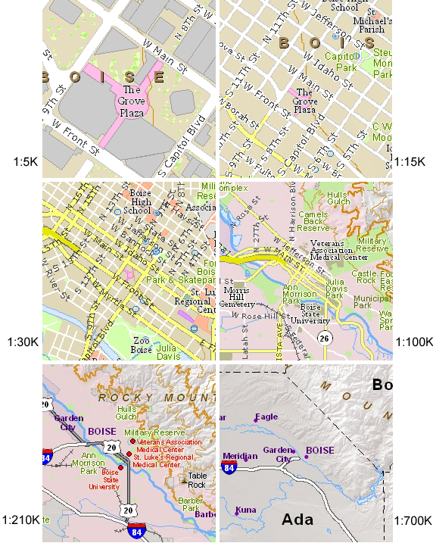

Figure 1. Segments of the topographic map design centered on downtown Boise for 1:5K, 15K, 30K, 100K, 210K, and 700K (viewed at 96dpi). Each of these map segments is associated with a vertical through the ScaleMaster diagram shown in Figure 2.
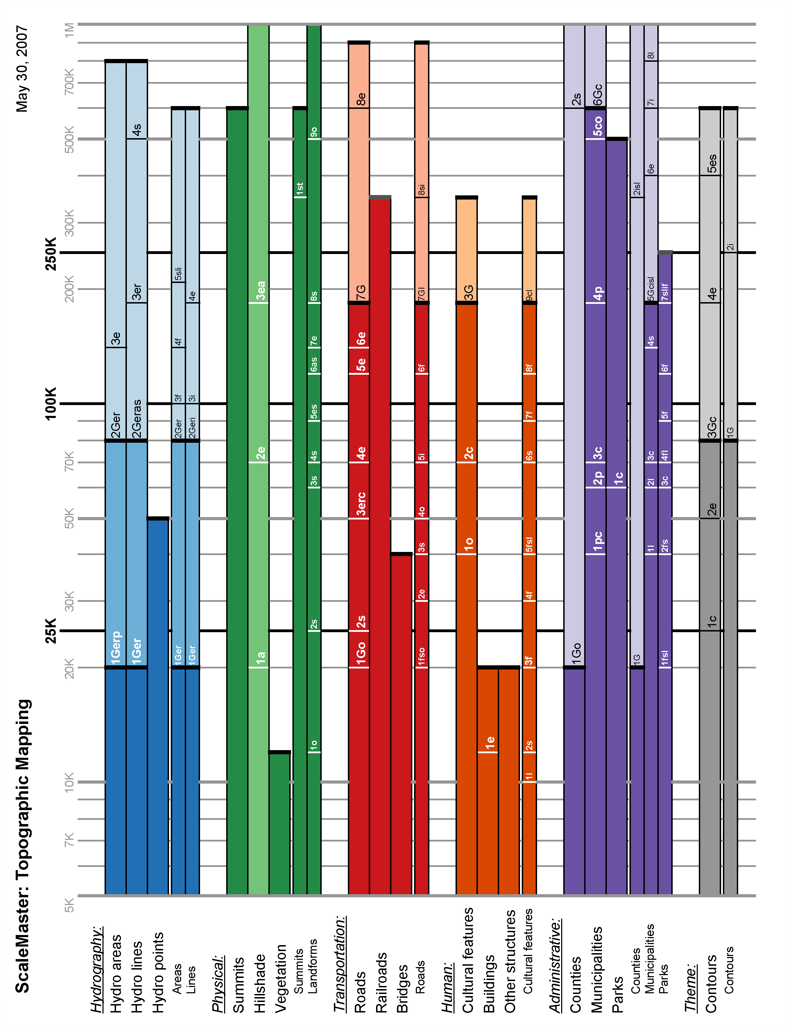

Figure 2. ScaleMaster diagram for topographic maps created for 1:5K to 1:1M.
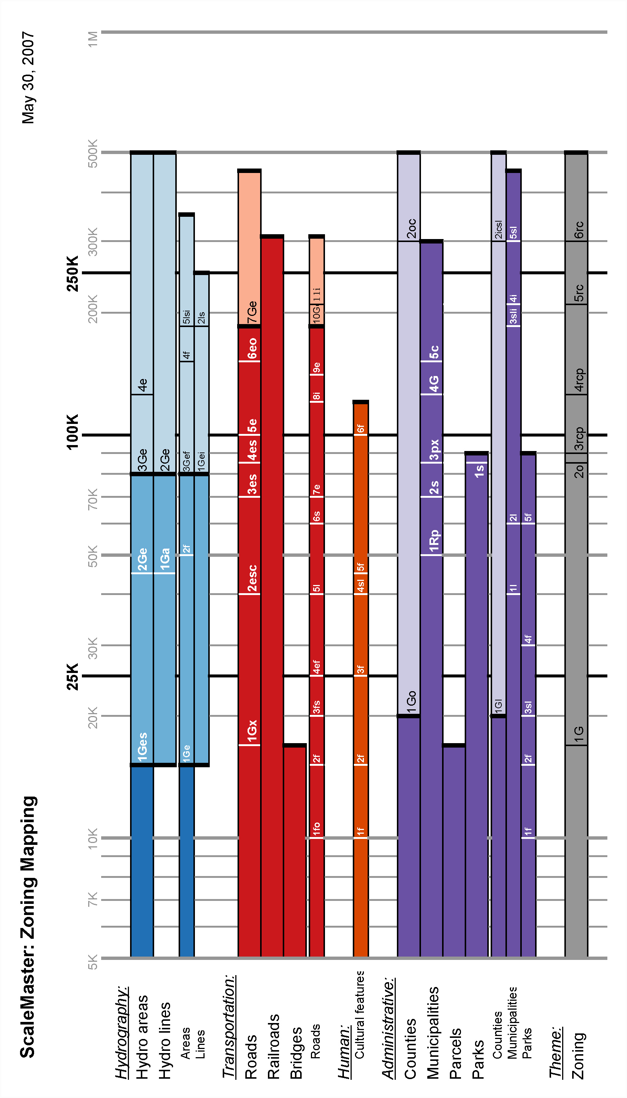

Figure 3. ScaleMaster diagram for zoning maps created for 1:5K to 1:500K.

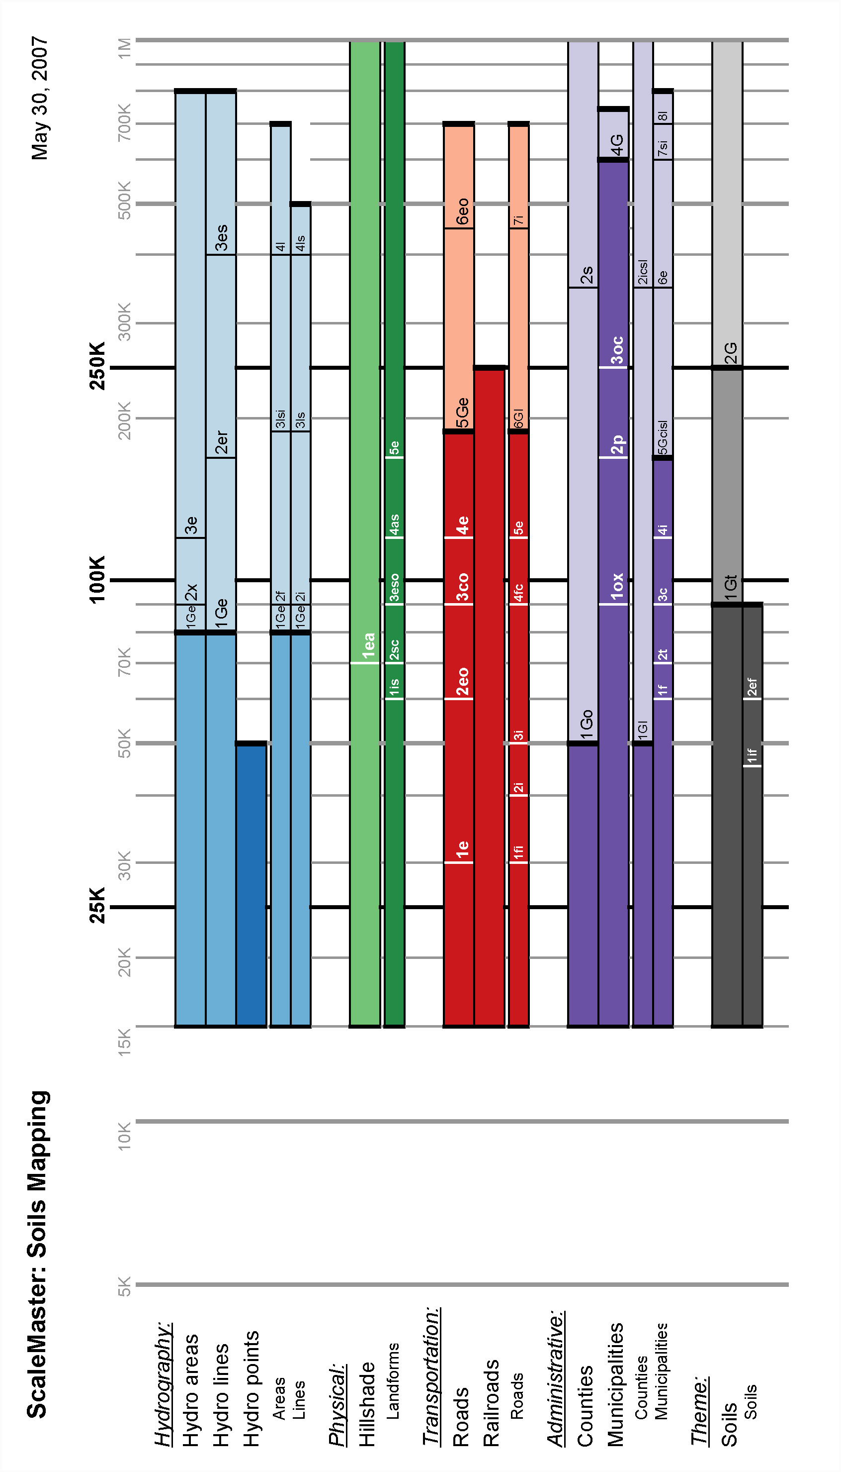

Figure 4. ScaleMaster diagram for soils maps created for 1:15K to 1:1M.

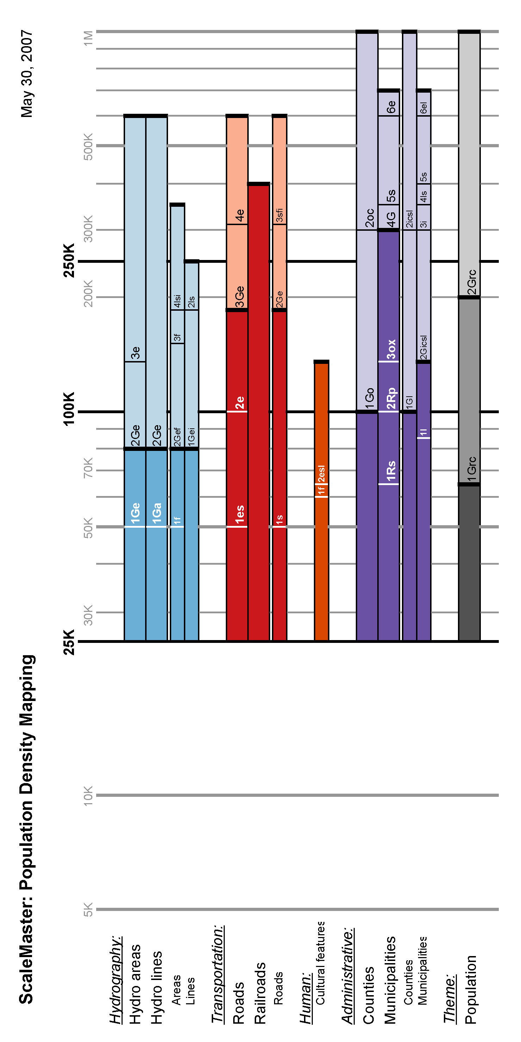

Figure 5. ScaleMaster diagram for population density maps for 1:25K to 1:1M.
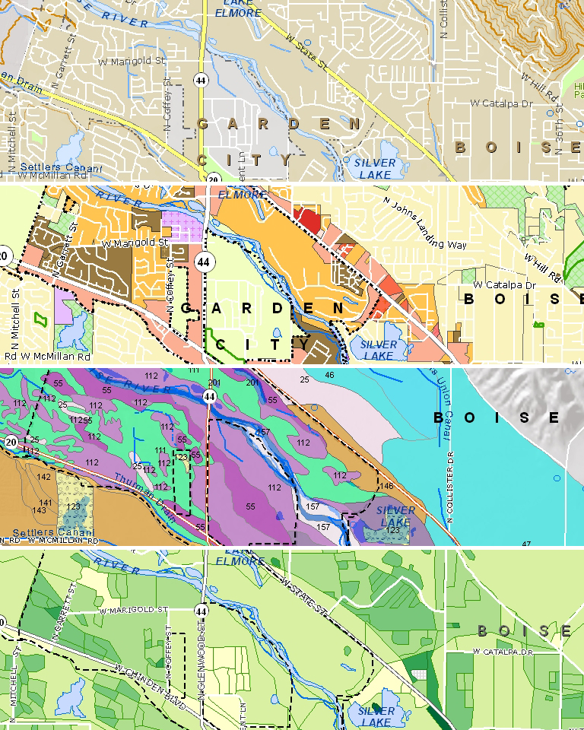

Figure 6. The same segment of all four map types at 1:30K scale and viewed at 96dpi. From top to bottom, the map types are topographic maps, zoning maps, soils maps and population density maps. They range from reference maps through infrastructure maps to thematic maps.
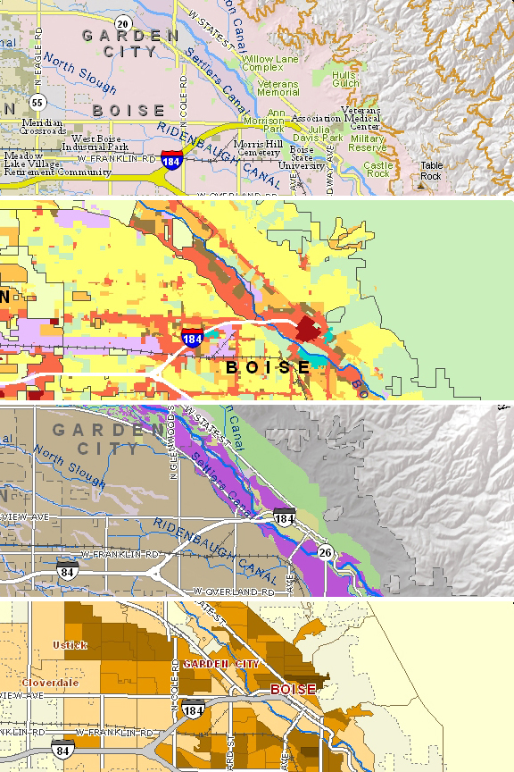

Figure 7. A common segment from all four map types at 1:150K scale.

